**CONFIGURACION DIALPLAN MX 10 DIGITOS**

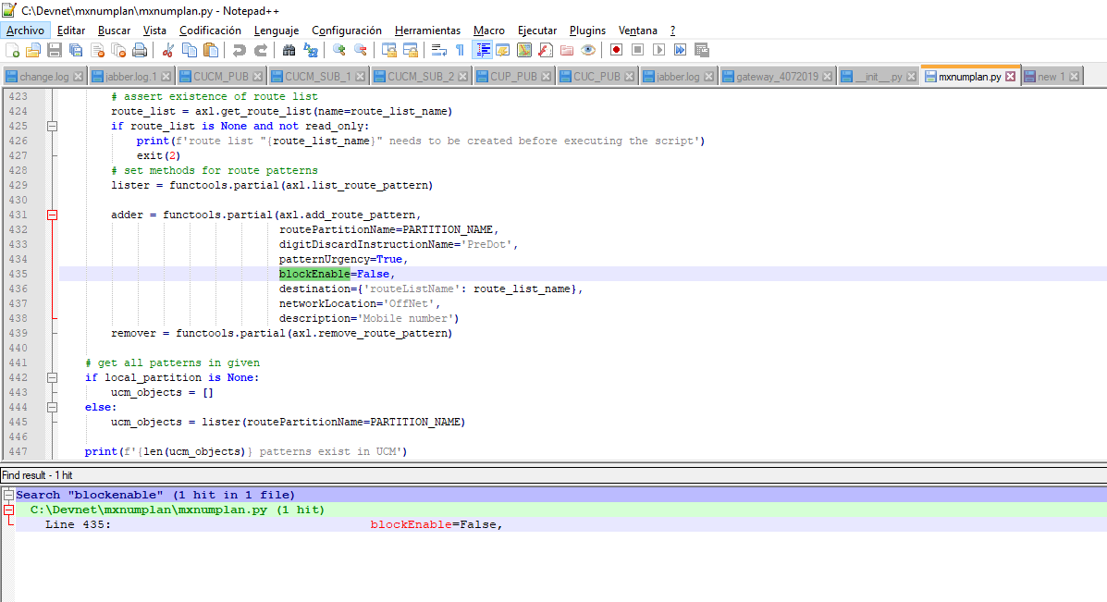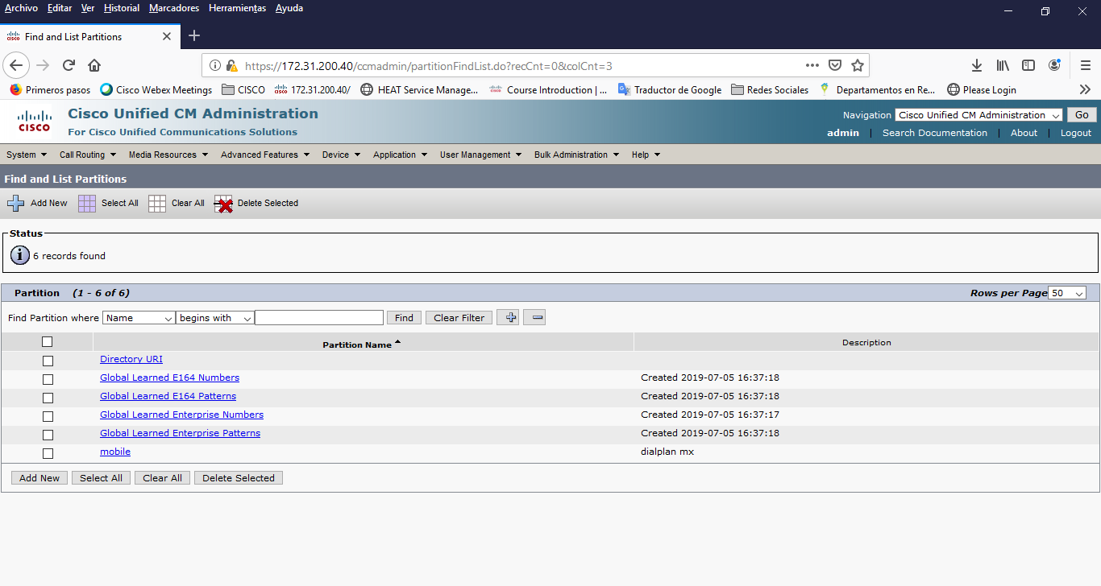

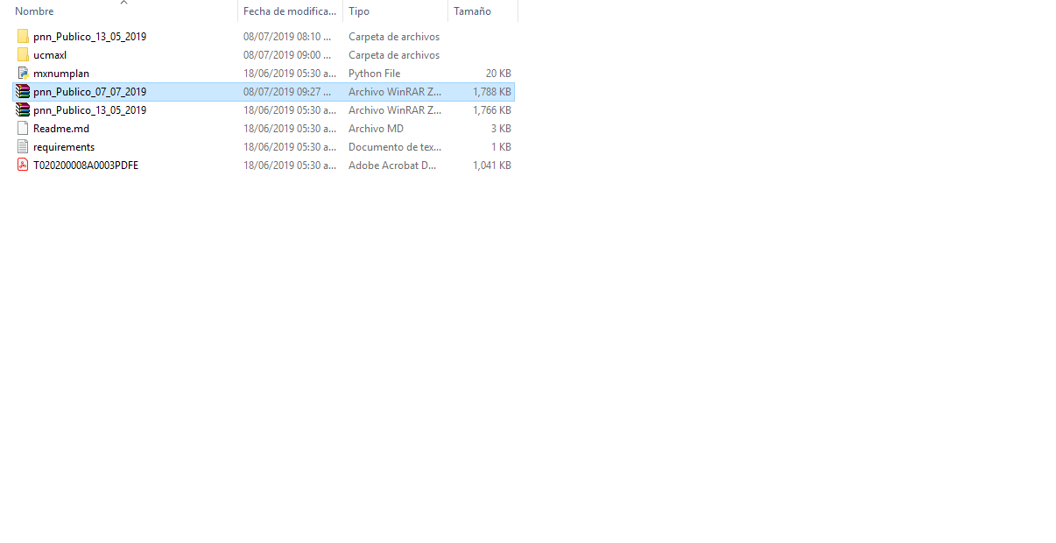

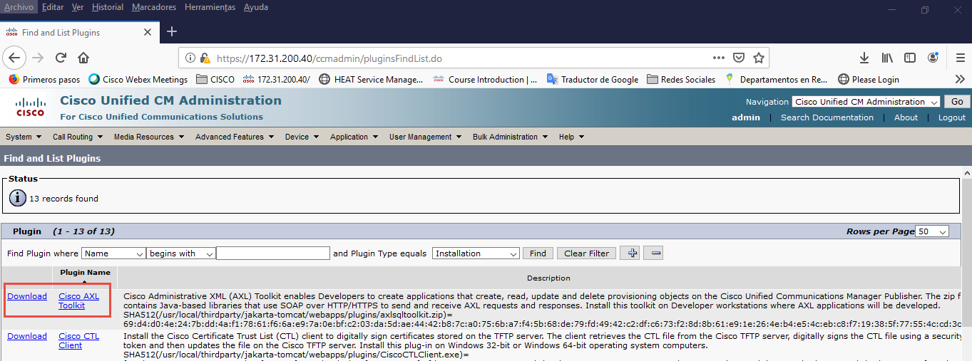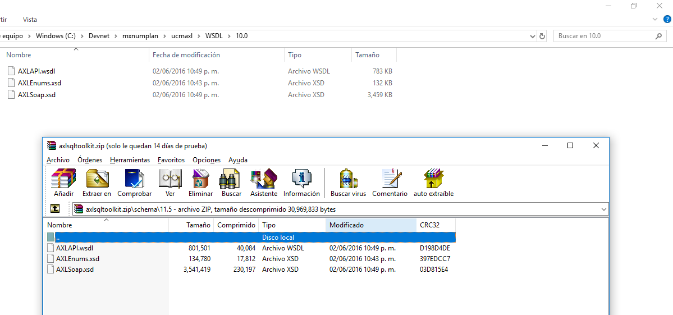

Realizar los siguientes pasos:

Microsoft Windows [Versión 10.0.17134.829]

(c) 2018 Microsoft Corporation. Todos los derechos reservados.

C:\Windows\system32>cd..

C:\Windows>cd..

C:\>cd DEvnet

C:\Devnet>cd mxnumplan

C:\Devnet\mxnumplan>python mxnumplan.py -h

Traceback (most recent call last):

File "mxnumplan.py", line 26, in <module>

import ucmaxl

File "C:\Devnet\mxnumplan\ucmaxl\__init__.py", line 4, in <module>

import zeep

ModuleNotFoundError: No module named 'zeep'

C:\Devnet\mxnumplan>python --version

Python 3.7.3

C:\Devnet\mxnumplan>pip install zeep

Collecting zeep

Retrying (Retry(total=4, connect=None, read=None, redirect=None, status=None)) after connection broken by 'NewConnectionError('<pip._vendor.urllib3.connection.VerifiedHTTPSConnection object at 0x00000218ABCA3048>: Failed to establish a new connection: [Errno 11001] getaddrinfo failed')': /simple/zeep/

Retrying (Retry(total=3, connect=None, read=None, redirect=None, status=None)) after connection broken by 'NewConnectionError('<pip._vendor.urllib3.connection.VerifiedHTTPSConnection object at 0x00000218ABCA3198>: Failed to establish a new connection: [Errno 11001] getaddrinfo failed')': /simple/zeep/

Retrying (Retry(total=2, connect=None, read=None, redirect=None, status=None)) after connection broken by 'NewConnectionError('<pip._vendor.urllib3.connection.VerifiedHTTPSConnection object at 0x00000218ABCA30F0>: Failed to establish a new connection: [Errno 11001] getaddrinfo failed')': /simple/zeep/

Retrying (Retry(total=1, connect=None, read=None, redirect=None, status=None)) after connection broken by 'NewConnectionError('<pip._vendor.urllib3.connection.VerifiedHTTPSConnection object at 0x00000218ABCA3400>: Failed to establish a new connection: [Errno 11001] getaddrinfo failed')': /simple/zeep/

Retrying (Retry(total=0, connect=None, read=None, redirect=None, status=None)) after connection broken by 'NewConnectionError('<pip._vendor.urllib3.connection.VerifiedHTTPSConnection object at 0x00000218ABCA3588>: Failed to establish a new connection: [Errno 11001] getaddrinfo failed')': /simple/zeep/

Could not find a version that satisfies the requirement zeep (from versions: )

No matching distribution found for zeep

C:\Devnet\mxnumplan>pip install zeep

Collecting zeep

Downloading https://files.pythonhosted.org/packages/5e/7e/31dc5db254f4bd788f03947bae4ee38117789f2d4872a4c11a05b57700db/zeep-3.4.0-py2.py3-none-any.whl (99kB)

100% |████████████████████████████████| 102kB 107kB/s

Collecting requests>=2.7.0 (from zeep)

Downloading https://files.pythonhosted.org/packages/51/bd/23c926cd341ea6b7dd0b2a00aba99ae0f828be89d72b2190f27c11d4b7fb/requests-2.22.0-py2.py3-none-any.whl (57kB)

100% |████████████████████████████████| 61kB 146kB/s

Collecting cached-property>=1.3.0 (from zeep)

Downloading https://files.pythonhosted.org/packages/3b/86/85c1be2e8db9e13ef9a350aecd6dea292bd612fa288c2f40d035bb750ded/cached_property-1.5.1-py2.py3-none-any.whl

Collecting lxml>=3.1.0 (from zeep)

Downloading https://files.pythonhosted.org/packages/c6/22/a43126b87020c325fac159bb3b7f4e7ea99e7b2594ce5b8fa23cfa6ee90d/lxml-4.3.4-cp37-cp37m-win_amd64.whl (3.6MB)

100% |████████████████████████████████| 3.6MB 71kB/s

Collecting isodate>=0.5.4 (from zeep)

Downloading https://files.pythonhosted.org/packages/9b/9f/b36f7774ff5ea8e428fdcfc4bb332c39ee5b9362ddd3d40d9516a55221b2/isodate-0.6.0-py2.py3-none-any.whl (45kB)

100% |████████████████████████████████| 51kB 302kB/s

Collecting six>=1.9.0 (from zeep)

Downloading https://files.pythonhosted.org/packages/73/fb/00a976f728d0d1fecfe898238ce23f502a721c0ac0ecfedb80e0d88c64e9/six-1.12.0-py2.py3-none-any.whl

Collecting attrs>=17.2.0 (from zeep)

Downloading https://files.pythonhosted.org/packages/23/96/d828354fa2dbdf216eaa7b7de0db692f12c234f7ef888cc14980ef40d1d2/attrs-19.1.0-py2.py3-none-any.whl

Collecting requests-toolbelt>=0.7.1 (from zeep)

Downloading https://files.pythonhosted.org/packages/60/ef/7681134338fc097acef8d9b2f8abe0458e4d87559c689a8c306d0957ece5/requests_toolbelt-0.9.1-py2.py3-none-any.whl (54kB)

100% |████████████████████████████████| 61kB 339kB/s

Collecting pytz (from zeep)

Downloading https://files.pythonhosted.org/packages/3d/73/fe30c2daaaa0713420d0382b16fbb761409f532c56bdcc514bf7b6262bb6/pytz-2019.1-py2.py3-none-any.whl (510kB)

100% |████████████████████████████████| 512kB 1.1MB/s

Collecting defusedxml>=0.4.1 (from zeep)

Downloading https://files.pythonhosted.org/packages/06/74/9b387472866358ebc08732de3da6dc48e44b0aacd2ddaa5cb85ab7e986a2/defusedxml-0.6.0-py2.py3-none-any.whl

Collecting appdirs>=1.4.0 (from zeep)

Downloading https://files.pythonhosted.org/packages/56/eb/810e700ed1349edde4cbdc1b2a21e28cdf115f9faf263f6bbf8447c1abf3/appdirs-1.4.3-py2.py3-none-any.whl

Collecting certifi>=2017.4.17 (from requests>=2.7.0->zeep)

Downloading https://files.pythonhosted.org/packages/69/1b/b853c7a9d4f6a6d00749e94eb6f3a041e342a885b87340b79c1ef73e3a78/certifi-2019.6.16-py2.py3-none-any.whl (157kB)

100% |████████████████████████████████| 163kB 234kB/s

Collecting urllib3!=1.25.0,!=1.25.1,<1.26,>=1.21.1 (from requests>=2.7.0->zeep)

Downloading https://files.pythonhosted.org/packages/e6/60/247f23a7121ae632d62811ba7f273d0e58972d75e58a94d329d51550a47d/urllib3-1.25.3-py2.py3-none-any.whl (150kB)

100% |████████████████████████████████| 153kB 394kB/s

Collecting idna<2.9,>=2.5 (from requests>=2.7.0->zeep)

Downloading https://files.pythonhosted.org/packages/14/2c/cd551d81dbe15200be1cf41cd03869a46fe7226e7450af7a6545bfc474c9/idna-2.8-py2.py3-none-any.whl (58kB)

100% |████████████████████████████████| 61kB 260kB/s

Collecting chardet<3.1.0,>=3.0.2 (from requests>=2.7.0->zeep)

Downloading https://files.pythonhosted.org/packages/bc/a9/01ffebfb562e4274b6487b4bb1ddec7ca55ec7510b22e4c51f14098443b8/chardet-3.0.4-py2.py3-none-any.whl (133kB)

100% |████████████████████████████████| 143kB 334kB/s

Installing collected packages: certifi, urllib3, idna, chardet, requests, cached-property, lxml, six, isodate, attrs, requests-toolbelt, pytz, defusedxml, appdirs, zeep

Successfully installed appdirs-1.4.3 attrs-19.1.0 cached-property-1.5.1 certifi-2019.6.16 chardet-3.0.4 defusedxml-0.6.0 idna-2.8 isodate-0.6.0 lxml-4.3.4 pytz-2019.1 requests-2.22.0 requests-toolbelt-0.9.1 six-1.12.0 urllib3-1.25.3 zeep-3.4.0

You are using pip version 19.0.3, however version 19.1.1 is available.

You should consider upgrading via the 'python -m pip install --upgrade pip' command.

C:\Devnet\mxnumplan>python mxnumplan.py -h

Traceback (most recent call last):

File "mxnumplan.py", line 28, in <module>

from bs4 import BeautifulSoup

ModuleNotFoundError: No module named 'bs4'

C:\Devnet\mxnumplan>pip install beatifulsoup4

Collecting beatifulsoup4

Could not find a version that satisfies the requirement beatifulsoup4 (from versions: )

No matching distribution found for beatifulsoup4

You are using pip version 19.0.3, however version 19.1.1 is available.

You should consider upgrading via the 'python -m pip install --upgrade pip' command.

C:\Devnet\mxnumplan>python -m pip install --upgrade pip

Collecting pip

Downloading https://files.pythonhosted.org/packages/5c/e0/be401c003291b56efc55aeba6a80ab790d3d4cece2778288d65323009420/pip-19.1.1-py2.py3-none-any.whl (1.4MB)

100% |████████████████████████████████| 1.4MB 217kB/s

Installing collected packages: pip

Found existing installation: pip 19.0.3

Uninstalling pip-19.0.3:

Successfully uninstalled pip-19.0.3

Successfully installed pip-19.1.1

C:\Devnet\mxnumplan>pip install beautifulsoup4

Collecting beautifulsoup4

Downloading https://files.pythonhosted.org/packages/1d/5d/3260694a59df0ec52f8b4883f5d23b130bc237602a1411fa670eae12351e/beautifulsoup4-4.7.1-py3-none-any.whl (94kB)

|████████████████████████████████| 102kB 159kB/s

Collecting soupsieve>=1.2 (from beautifulsoup4)

Downloading https://files.pythonhosted.org/packages/35/e3/25079e8911085ab76a6f2facae0771078260c930216ab0b0c44dc5c9bf31/soupsieve-1.9.2-py2.py3-none-any.whl

Installing collected packages: soupsieve, beautifulsoup4

Successfully installed beautifulsoup4-4.7.1 soupsieve-1.9.2

C:\Devnet\mxnumplan>python mxnumplan.py -h

usage: mxnumplan.py [-h] [--ucm UCM] [--user USER] [--pwd PWD]

[--fromfile FROMFILE] [--readonly] [--routelist ROUTELIST]

[--analysis]

Provision blocking translation patterns or route patterns to cover all mobile

phone number in Mexico. The blocking translation patterns or route patterns

are put into a 'mobile' partition which is also created if it doesn't exist.

If a route list is specified using --routelist then route patterns are

provisioned pointing to that route list.

optional arguments:

-h, --help show this help message and exit

--ucm UCM IP or FQDN of UCM publisher host. If ucm is not given

then only the patterns are printed

--user USER AXL user with write access to UCM

--pwd PWD Password for AXL user with write access to UCM

--fromfile FROMFILE name of ZIP file to read patterns from. If the file

name is given as "." then we take the latest

pnn_Publico_??_??_????.zip

--readonly Don't write to UCM. Existing patterns are read if

possible.

--routelist ROUTELIST

provision route patterns pointing to given route list

--analysis If present, then compare patterns of existing data

sets

C:\Devnet\mxnumplan>

C:\Devnet\mxnumplan>python mxnumplan.py --ucm 172.31.200.40 --user orben --pwd C1sc0123

reading patterns...

Accessing numbering plan information web site at https://sns.ift.org.mx:8081/sns-frontend/planes-numeracion/descarga-publica.xhtml ...

Requesting ZIP from web site...

Reading ZIP 'pnn_Publico_07_07_2019.zip’ from web site...

Reading number ranges from pnn_Publico_07_07_2019.csv...

got 61752 mobile patterns

sorting patterns...

expanding patterns...

expanded to 148255 patterns

Summarize 10: 148255->148255

Summarize 9: 148255->148255

Summarize 8: 148255->131515

Summarize 7: 131515->46727

Summarize 6: 46727->9030

Summarize 5: 9030->7766

Summarize 4: 7766->7759

Summarize 3: 7759->7759

\+522211[012346789]XXXXX

\+5222115[012356789]XXXX

\+52221154[01234]XXX

\+522212[012345678]XXXXX

\+5222129[012456789]XXXX

\+52221293[0123]XXX

\+522213[012356789]XXXXX

\+5222134[012456789]XXXX

\+52221343[012]XXX

\+522214[012345789]XXXXX

\+5222146[012456789]XXXX

\+52221463[012345]XXX

\+522215[02]XXXXX

\+5222151[012356789]XXXX

\+52221514[0123]XXX

\+5222153[012]XXXX

\+52221533[012345678]XXX

\+522221[01]XXXXX

\+5222212[01345678]XXXX

\+522221225XXX

\+5222213[1234569]XXXX

\+5222214[02356789]XXXX

\+5222215[012456789]XXXX

\+5222216[01234567]XXXX

\+52222168[2367]XXX

\+5222217[01234567]XXXX

\+52222178[3456789]XXX

\+5222218[12345689]XXXX

\+52222180[3456789]XXX

\+5222219[0123489]XXXX

\+52222195[789]XXX

\+52222196[0139]XXX

\+52222197[56789]XXX

\+5222220XXXXX

\+5222221[257]XXXX

\+522222214XXX

\+5222223[89]XXXX

\+5222225[01245689]XXXX

\+5222226[02579]XXXX

\+522222689XXX

\+5222227[025678]XXXX

\+522222731XXX

\+522222798XXX

\+52222280XXXX

\+522222833XXX

\+5222229[239]XXXX

\+522223[45]XXXXX

\+5222230[01245678]XXXX

\+5222231[023456789]XXXX

\+52222311[356789]XXX

\+5222232[01234578]XXXX

\+522223261XXX

\+5222233[023456789]XXXX

\+52222331[23456789]XXX

\+5222236[0123459]XXXX

\+52222366[56789]XXX

\+52222367[347]XXX

\+5222237[0134678]XXXX

\+52222375[56789]XXX

\+5222238[013456789]XXXX

\+5222239[0134678]XXXX

\+52222392[19]XXX

\+522224[49]XXXXX

\+5222240[0126]XXXX

\+52222407[23456789]XXX

\+52222408[789]XXX

\+5222241[01234567]XXXX

\+52222418[6789]XXX

\+5222242[234569]XXXX

\+52222420[456789]XXX

\+52222421[256789]XXX

\+52222427[123456789]XXX

\+52222428[123456789]XXX

\+5222243[03456789]XXXX

\+522224319XXX

\+52222432[123456789]XXX

\+5222245[012356789]XXXX

\+5222246[01345689]XXXX

\+5222247[0134569]XXXX

\+52222472[5678]XXX

\+5222248[014679]XXXX

\+52222485[356789]XXX

\+52222488[23456789]XXX

\+5222250[1456789]XXXX

\+5222251[01236789]XXXX

\+5222252XXXXX

\+5222253[012345679]XXXX

\+52222538[56789]XXX

\+5222254[012346789]XXXX

\+52222545[3456789]XXX

\+5222255[046789]XXXX

\+52222551[13456789]XXX

\+5222256[013456789]XXXX

\+5222257[25789]XXXX

\+5222258[0145678]XXXX……ZZzzzzz

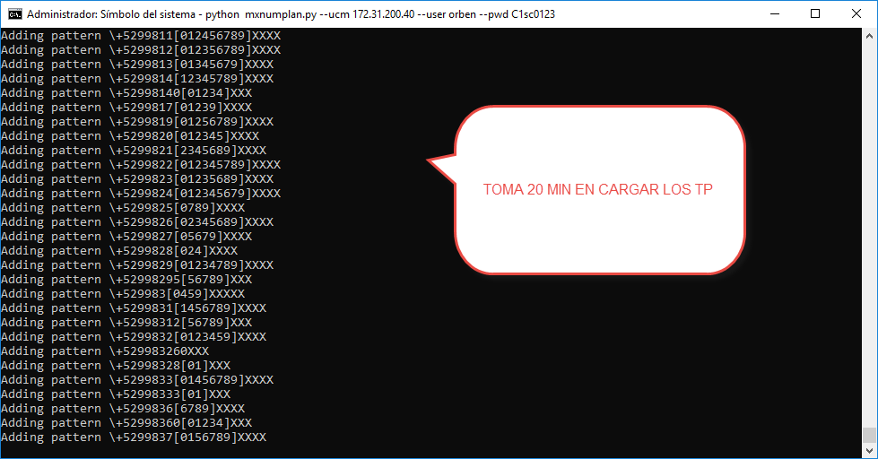

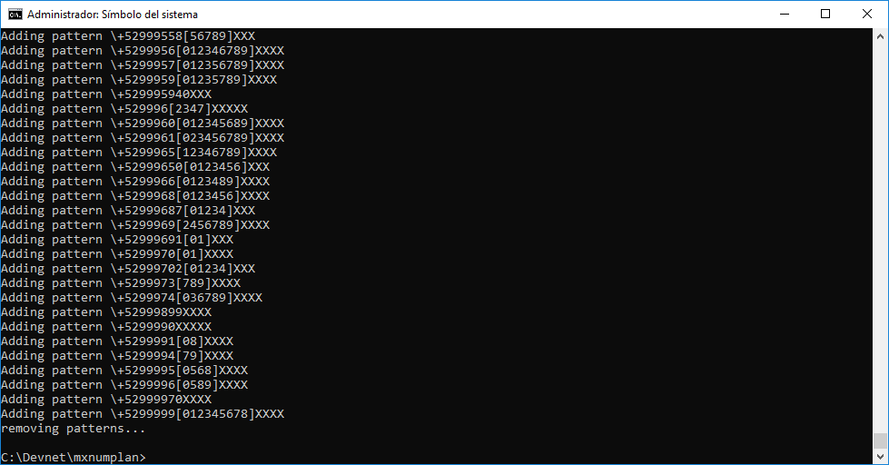

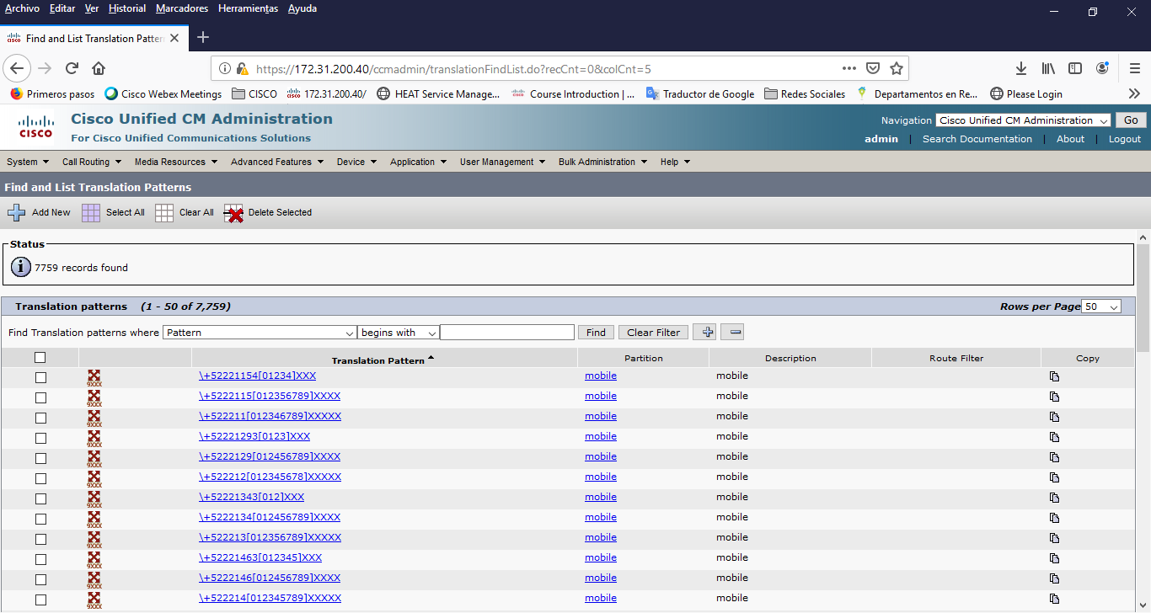

FIN